**PES University, Bangalore**

(Established under Karnataka Act No. 16 of 2013)

**STATISTICS FOR DATA SCIENCE**

**SUBJECT CODE: UE19CS203**

**Project Title: STUDY OF AIR QUALITY IN INDIA**

Section: D

Team members:

MEENAKSHI SURESH: PES2UG19CS228

LALITHA SRAVANTI DASU: PES2UG19CS201

MANASWINI RATHORE: PES2UG19CS217

N R SAMHITHA RAO: PES2UG19CS243

**1.Abstract** :

In December 2019, the outbreak of viral disease known as Covid-19 had spread in almost every part of the world and has been declared a global pandemic in March 2020 by World Health Organization (WHO). The corona virus outbreak has emerged as one of the deadliest pandemics of all time in human history. The ongoing pandemic of COVID-19 has forced several countries of the world to observe complete lockdown forcing people to live in their homes. India also faced the phase of total lockdown for 21 days (in first phase) to avoid the spread of coronavirus to the maximum possible extent. This lockdown impacted the pollution levels of environment and improved air and water quality in the short span owing to very less human activities.

The following project seeks to study the pollution levels of various cities in the country and how it has changed during the course of the lockdown during the ongoing pandemic. The dataset has been obtained from https://www.kaggle.com/rohanrao/air-quality-data-in-india and various conclusions have been drawn from this.

The results are presented with future perspectives to mitigate air pollution in near future by adopting the short and periodical lockdown as a tool.

**2. Introduction**:

The basic idea is to study pollution levels in the cities of India and to then compare how it has been affected during lockdown and to infer if the changes were positive or not. From this dataset, various pollution determining parameters have been selected spanning from year 2017 till September 2020.

The air quality index (AQI) is defined as ratios of the measured concentration of the atmospheric pollutants to their standard prescribe values. Mathematically, the AQI can be evaluated by using following equation for primary pollutants,

The sPM2.5, sSO2, sNO2 are ambient air quality standards as given by the Central Pollution Control Board of India (CPCB) and PM2.5, SO2 and NO2 represent the actual observational values of pollutants. The AQI was calculated by using mass concentration of these three primary pollutants (PM2.5, SO2 and NO2) for all specified locations. The high AQI values represent a higher level of atmospheric pollutants at the monitoring site. The AQI scale can be divided into six different categories as per the range and associated health impacts .

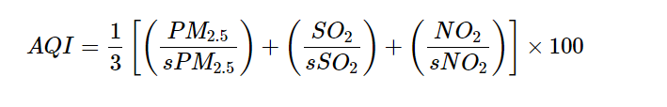

These parameters have been used to hypothesize and infer several conclusions alongside visualization via graphical representation which can help to reduce future pollution rates possibly.

**3. Dataset** :

The dataset has been taken from - <https://www.kaggle.com/rohanrao/air-quality-data-in-india>

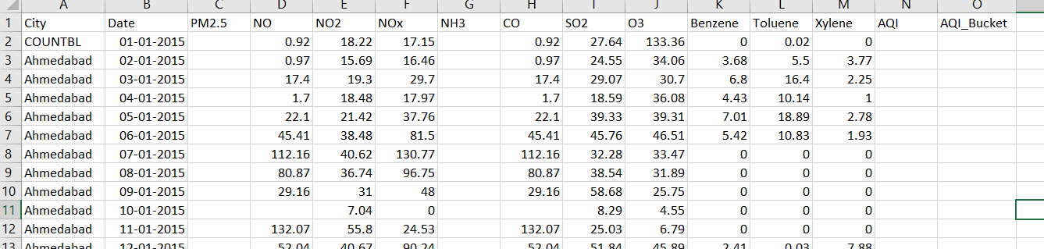

It contains the following columns explained below:

Column 1- City: The Indian city in which the observation was made.

Column 2- Date: The date on which the observation was made.

Column 3- PM2.5: Particulate Matter 2.5-micrometer in ug / m3. This refers to tiny particles or droplets in the air that are two and a half microns or less in width.

Column 4- NO: Nitric Oxide in ug / m3. Microgram per cubic metre.

Column 5- NO2: Nitric Dioxide in ug / m3. Microgram per cubic metre.

Column 6- NOx: Any Nitric x-oxide in ppb. Parts per billion.

NOx gases react to form smog and acid rain as well as being central to the formation of fine particles (PM) and ground level ozone.

Column 7-NH3: Ammonia in ug / m3. Microgram per cubic metre.

Column 7- CO: Carbon Monoxide in mg / m3. Milligram per cubic metre.

Column 8- SO2: Sulphur Dioxide in ug / m3. Microgram per cubic metre.

Column 9- O3: Ozone in ug / m3. Microgram per cubic metre.

Column 10- Benzene: Benzene in ug / m3. Microgram per cubic metre.

Column 11- Toulene: Toulene in ug / m3. Microgram per cubic metre.

Column 12- Xylene: Xylene in ug / m3. Microgram per cubic metre.

Column 10- AQI: Air Quality Index. Air quality is a measure of how clean or polluted the air is.

Column 11- AQI Bucket: Air Quality Index bucket. Relationship between AQI and AQI Bucket:

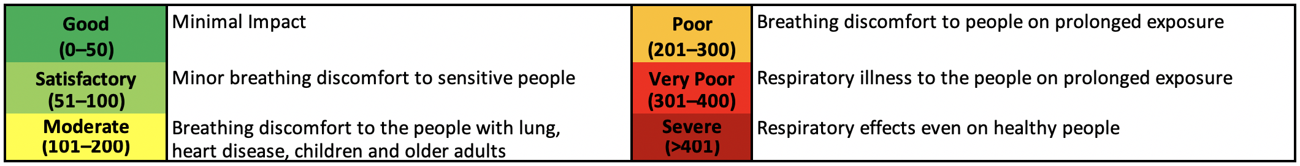

**4. Preprocessing or Data Cleaning** :

The data was first divided into sub data sets per city. The following cleaning techniques were then applied to the subsets:

1. Deletion of columns having greater than 35% NULL values.

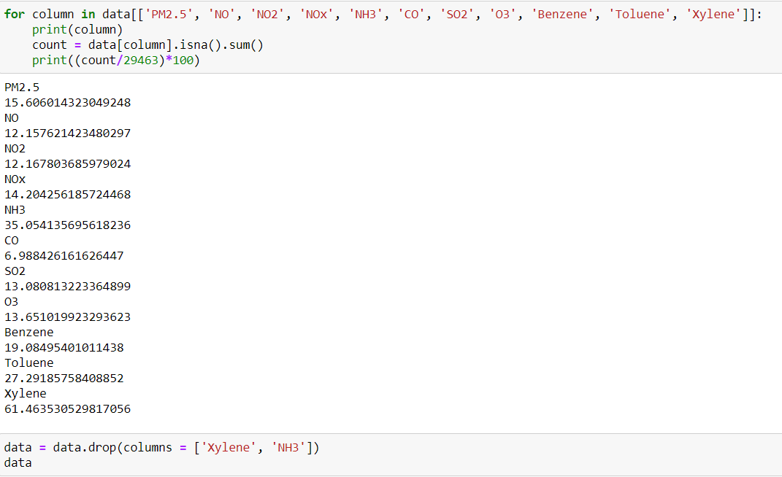

1. Replacing NULL values of continuous variables with the city means.

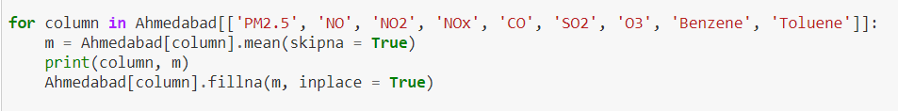

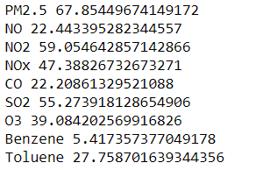

1. Replacing NULL values of categorical variables with the city modes.

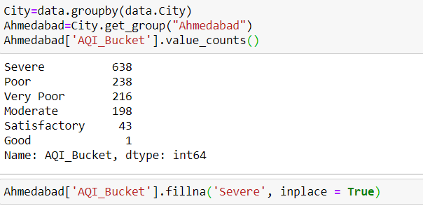

1. Changing the timestamp of dates from type “string” to type “date”.







1. Fixing inconsistent case by converting qualitative variables to lowercase.



1. Deletion of rows having dates falling in 2015, 2016 due to NULL values and simplification.





The same procedure was applied to 15 cities. Some cities were eliminated due to large percentage of null values/inconsistent values.

|  |  |
| --- | --- |
| Dataset before cleaning:  [Columns 46-72] | Dataset after cleaning:  [Columns 46-73] |

**5. Exploratory Data Analysis** :

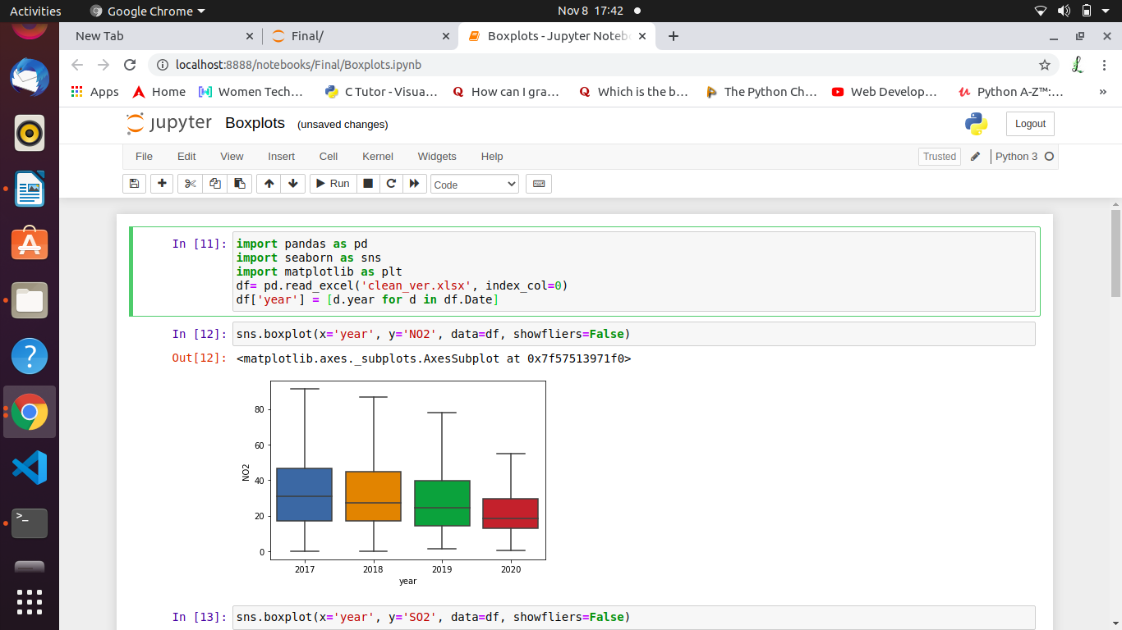

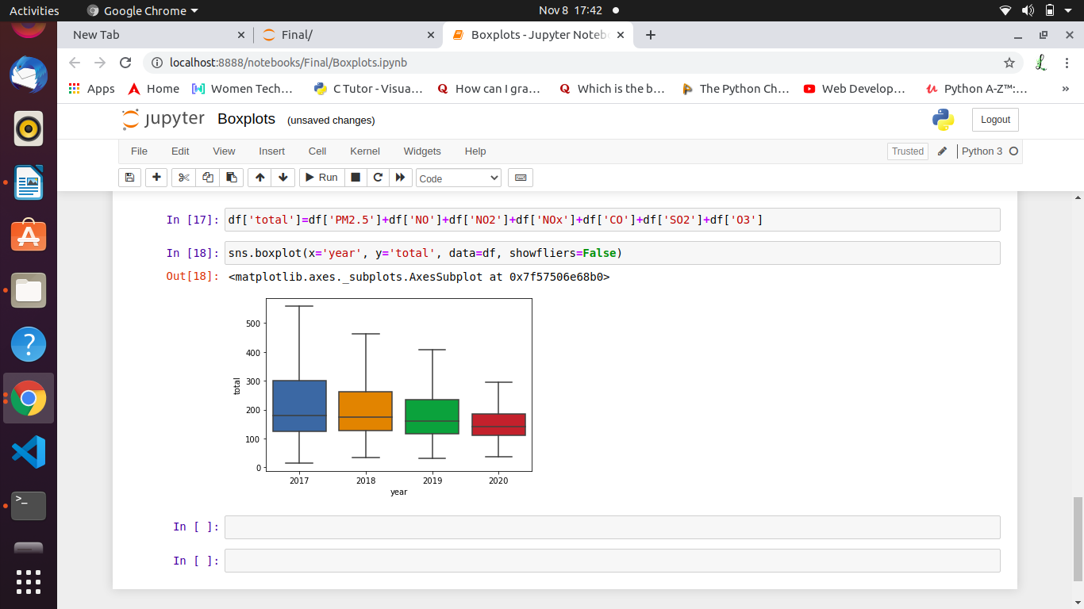

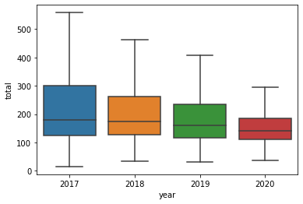

The above boxplot represents the total pollutants present in the years 2017 to 2020. It is evident that in 2020 the average total pollutants is the least.

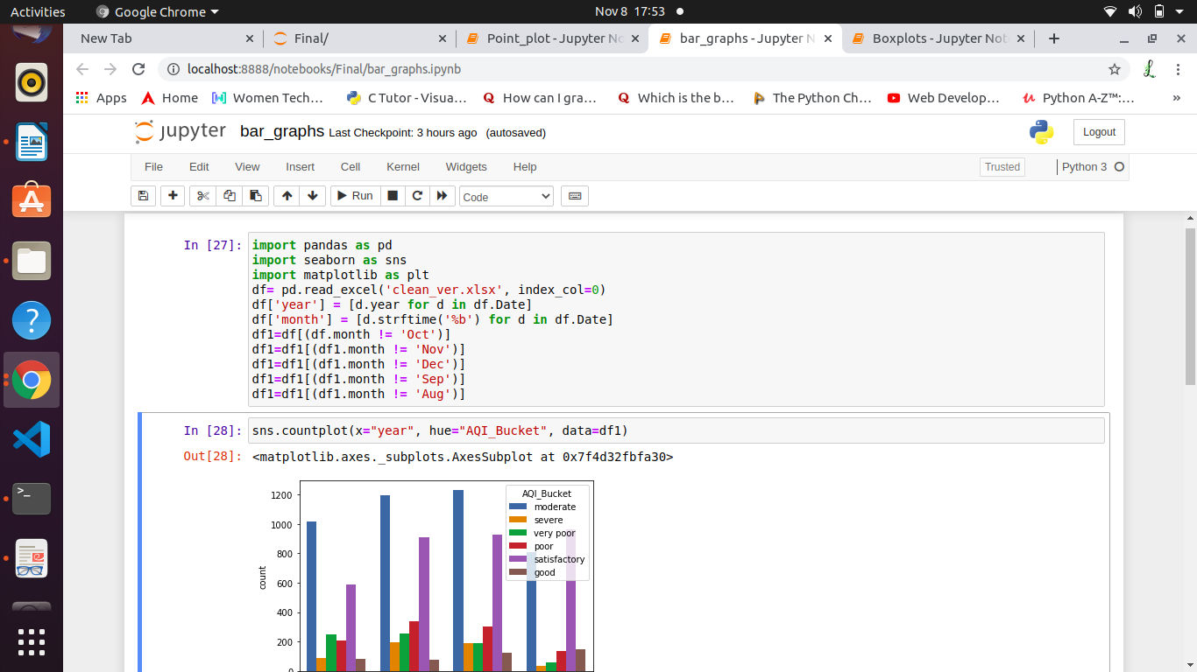

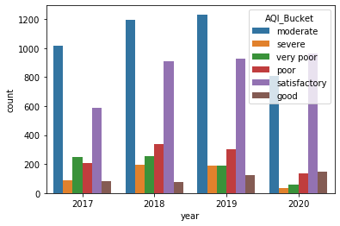

The following bar graph represents the number of days that had AQI Bucket moderate, very poor, satisfactory, severe, poor and good. As we can see, the year 2020 has the least number of days that have poor and very poor air quality and most number of good and satisfactory. In the above plot, we have considered only till the month of July for 2017,2018,2019 for accuracy since we have data till July for 2020.

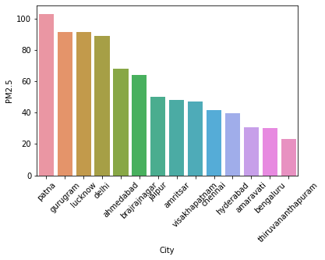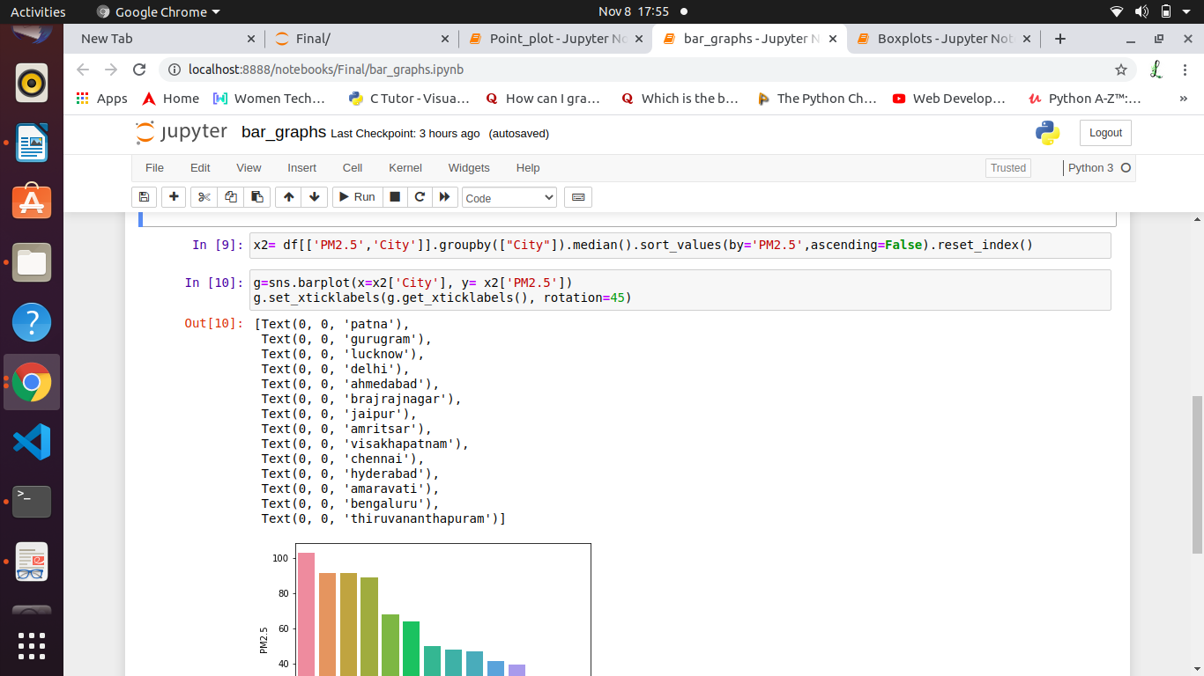

The above bar graph represents the PM 2.5 value for various cities. This graph shows that Patna has the most amount of particulate matter and Thiruvananthauram with the least.

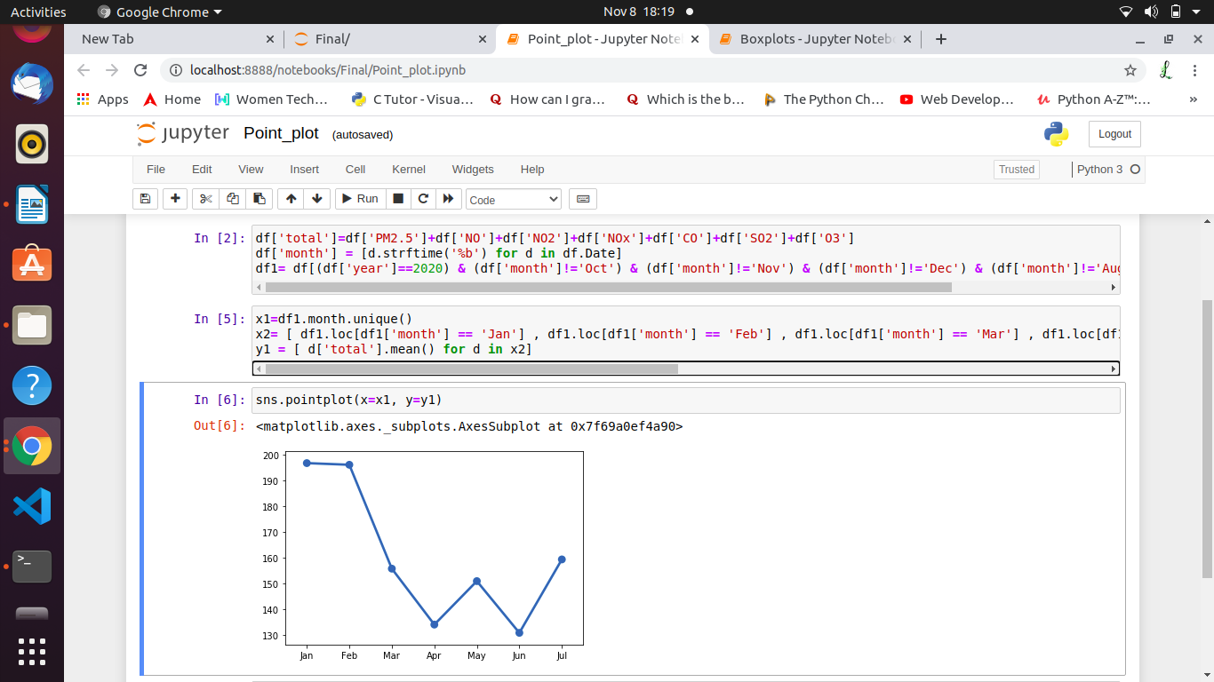

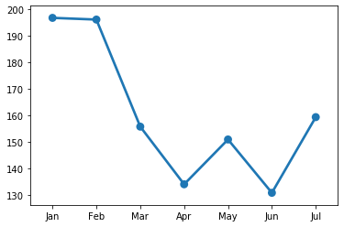

The above point plot represents the mean of total pollutants in 2020 from January to September. It is observed that there is a fall in the mean value when the lockdown started and increases when it was lifted.

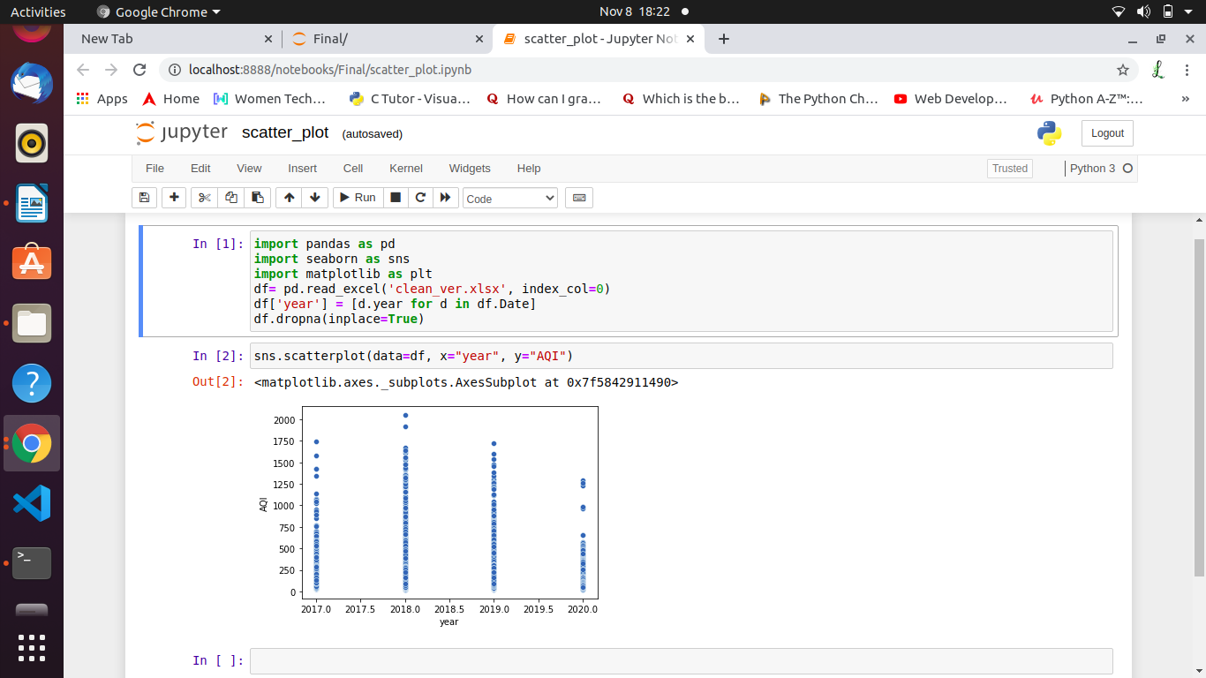

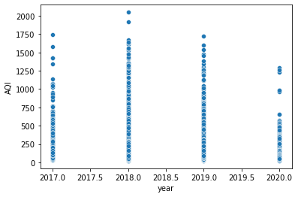

The above scatter plot represents Year vs AQI value. It is clear that the maximum AQI value is the least in the year 2020.

From the above graphs, we can say that the lockdown helped improving the air quality in various cities. We can also say tell say that Patna has been the most polluted city during the years 2017-2020 (september) and Thiruvananthapuram the least.

**6. Normalization and Standardization** :

Need for Normalization

* Reduce duplicate data
* Making data analysis easier as the data becomes significantly easier to sort through
* Makes the database more logical and natural

**Normalization**

Scales all the values of a column between the values 0 to 1.

Before Normalization: the data is shown before the normalization is applied



After Normalization:



Graph for the O3 levels:



**Standardization**

Transforms the data to have the mean equal to 0 and variance equal to 1.

Let’s take the column AQI. First, we need to standardize the data.

Before:







Fitting the data:



Mean and Variance after Standardization:



Thus, mean is 0 and variance is 1.

Combining multiple columns and fitting them into one dataframe:

**7. Hypothesis Testing** :

The Hindu newspaper reported a study which claims that on an average, the Air Quality had improved by nearly 65% throughout the country.

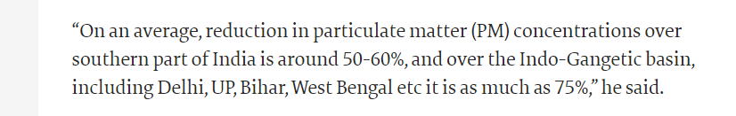

To test this theory, using the data from the data set that has been chosen, Null Hypothesis Ho is stated as follows, “AQI during lockdown is assumed to be nearly 65% or less than that of the usual air quality”. Alternate Hypothesis H1 is stated as follows “ AQI remains to be more than 65% of the usual AQI ”.

To do so, first the desired Dataset was segregated to reflect values only during lockdown.

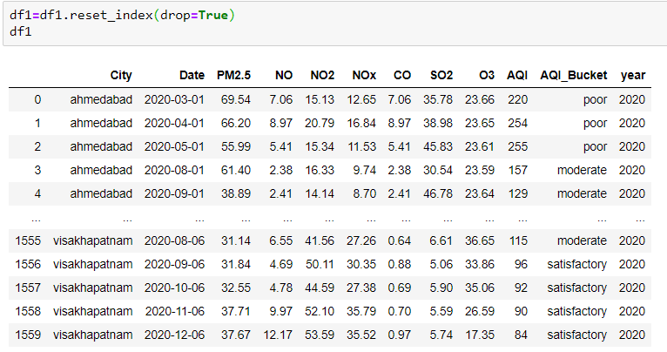

Then the hypothesis test which is one tailed was performed with following results:

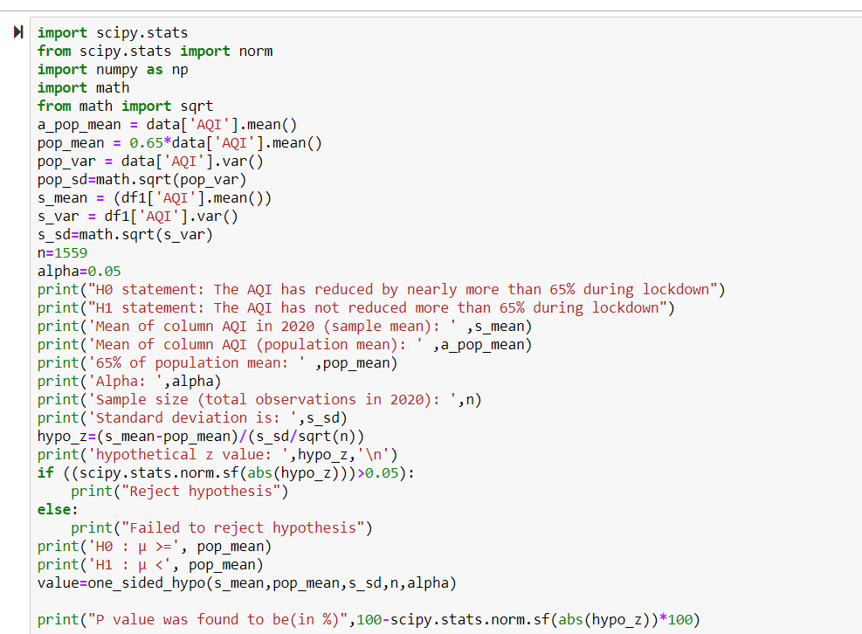

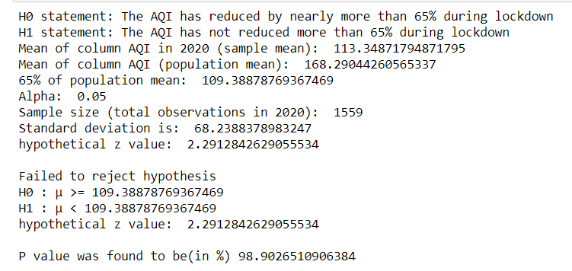

As P value is 98.90% which means that the probability of our assumption being correct was 98.9%, it can be safe to accept hypothesis or at least it is plausible that our statement is correct with accuracy of 98.9%.

**8. Correlation**:

In our study we have considered two examples for relation, namely, the relation between pollution control in the lockdown period using AQI as reference, and a case study of Delhi’s increasing pollution levels in 2018 which led to smog effect.

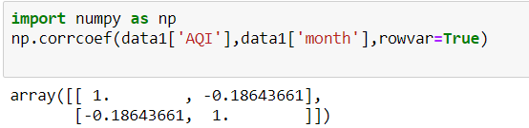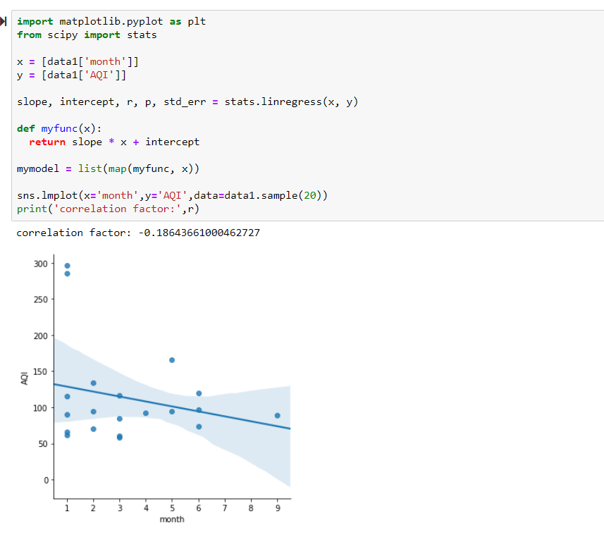

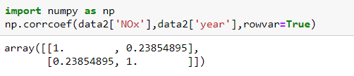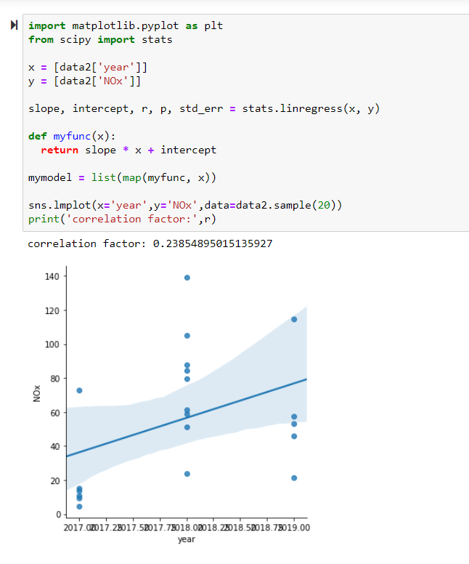

In the first graph it can be observed that pollution has rapidly decreased during lockdown, and it has a negative correlation.

In the second graph it is observed that Delhi’s production of NOx chemicals had increased over the past 3 years which would have reached dangerous levels as seen with the positive correlation.

**9. Results and Discussion**:

Throughout the report multiple examples to display the effect of lockdown on air quality in India has been demonstrated. The lessons learnt from the COVID-19 pandemic can be utilised to target source specific actions leading to maximum improvement in ambient air quality. In conclusion, results of the present study indicate a sharp decline in overall air quality indexes and in the concentration of primary air pollutants.. However, such a lockdown cannot be planned in normal conditions in such a huge country and therefore it cannot be considered as a permanent solution. Nevertheless, taking lessons from the present lockdown and emerging and foreseen environmental scenarios, we propose following prospective measures that can be adopted in future to mitigate air pollution.